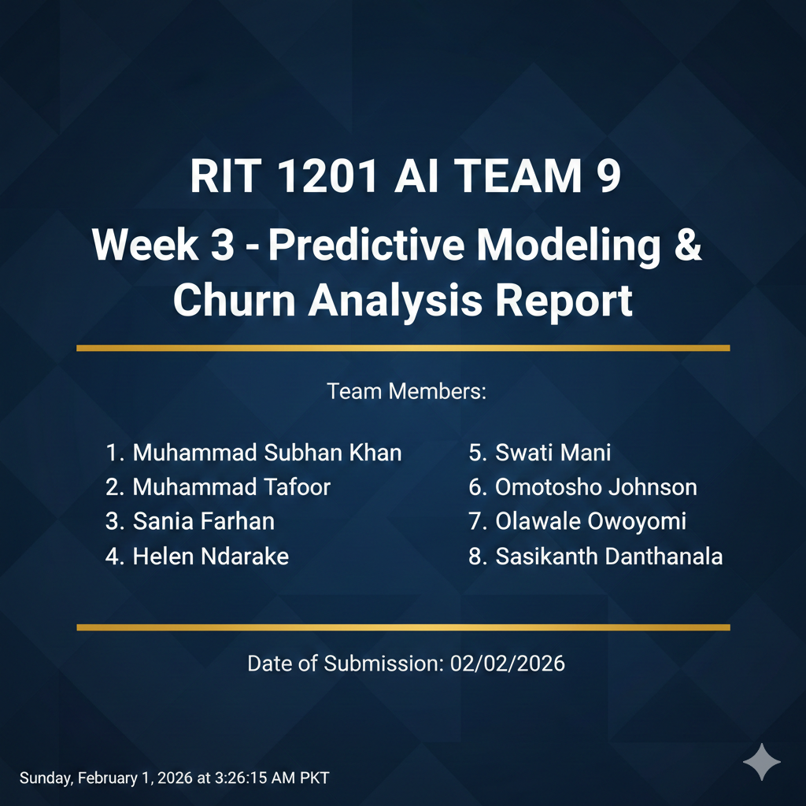


1. Introduction:
Student retention is a key performance indicator for educational and opportunity-based platforms. While a consistent number of learners register for opportunities, a notable proportion of students do not successfully progress through the application or completion process.
The purpose of this report is to perform a comprehensive churn analysis using cleaned and preprocessed learner data in order to identify behavioral and demographic factors that contribute to student drop-offs. The analysis combines exploratory data analysis and predictive modeling to support data-driven retention strategies.
This work aims to help stakeholders better understand engagement risks and design targeted interventions to improve student outcomes.

2. Problem Statement
Although many students sign up for opportunities, a considerable number fail to complete or successfully progress in the application lifecycle. This disengagement results in lower program effectiveness, reduced utilization of opportunities, and missed learning outcomes for students.
The core problem addressed in this report is:
How can we identify students who are likely to disengage early and understand the key factors that drive student churn in order to improve overall retention?
This analysis focuses on uncovering behavioral signals, demographic patterns, and application timeline characteristics that can be used to detect at-risk students at an early stage.

3. Dataset Overview:
The dataset contains learner-level records with information related to:
- signup timestamps
- application timing
- opportunity characteristics
- demographic attributes
- application outcome status
Key fields used in this analysis include:
- Learner SignUp DateTime
- Age
- Gender
- Country
- Days_To_Apply
- Opportunity_Duration_Days
- Opportunity Category
- Status Description
The dataset has already undergone data cleaning and preprocessing during the previous project phase.

4. Data Preparation:
4.1 Data Cleaning
The following data preparation steps were applied prior to modeling and analysis:
- Missing values in key numerical and date fields were handled using appropriate imputation or exclusion rules.
- Duplicate learner and opportunity records were removed.
- Date fields were standardized to consistent datetime formats.
- Invalid and inconsistent application timelines were corrected or excluded.
These steps ensured that the dataset was reliable for behavioral analysis and predictive modeling.

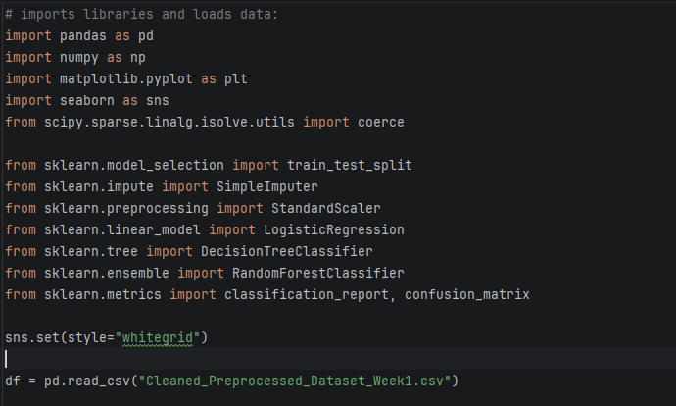
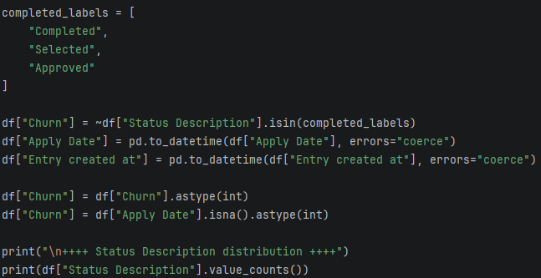

4.2 Feature Selection
Features were selected based on their relevance to student engagement and application behavior. The main features used in this study are:
- Age
- Days_To_Apply
- Opportunity_Duration_Days
These features capture both demographic and behavioral dimensions that are known to influence student engagement and completion likelihood.

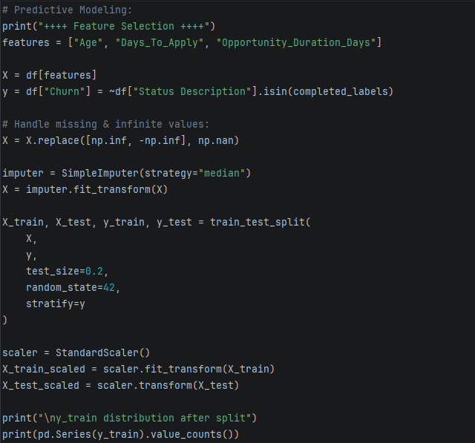

5. Churn Definition and Justification:
Because the dataset does not contain an explicit churn label, churn was defined based on application outcome behavior.
A student is considered not churned (retained) if their application status indicates successful progression or completion. A student is considered churned if their application status reflects unsuccessful progression or incomplete engagement.

Formally:
Students are labelled as retained (Churn = 0)
If their Status Description belongs to successful outcome categories such as:
- Completed
- Accepted
- Approved
All other application statuses are labeled as churned (Churn = 1).
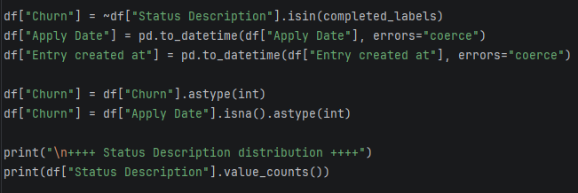
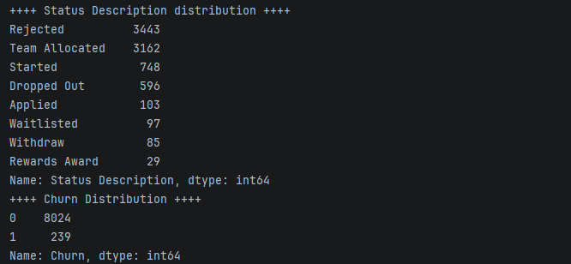

Justification
This definition reflects real operational behavior students who fail to reach a successful outcome effectively represent disengaged or dropped learners. This approach aligns with practical churn modeling in education and digital learning platforms, where behavioral completion is used as a proxy for retention.
This definition allows early identification of students who fail to progress beyond key engagement milestones.

6. Exploratory Data Analysis (EDA):
6.1 Descriptive Statistics
Descriptive analysis shows substantial variation in:
- Application timelines.
- Learner age groups.
- Engagement behavior across different countries and opportunity categories.
The distribution of Days_To_Apply indicates a strong long-tail pattern, suggesting that a portion of students delay their application significantly.

6.2 Churn Distribution
The churn distribution indicates that a noticeable segment of students does not reach a successful application outcome. This confirms the relevance of churn modeling for this dataset.
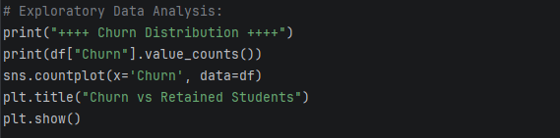
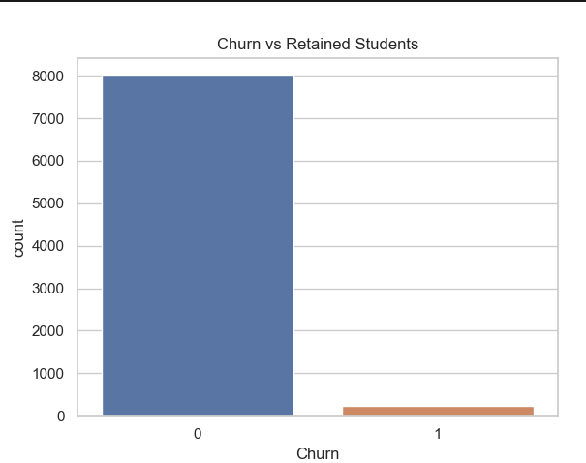
Count-plot: Churn vs Retain Students

6.3 Age and Churn
Age-based analysis shows moderate differences in churn behavior. Younger learners tend to exhibit greater variability in engagement timelines, while older learners display more stable application behavior.
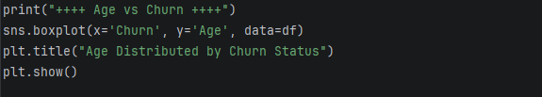

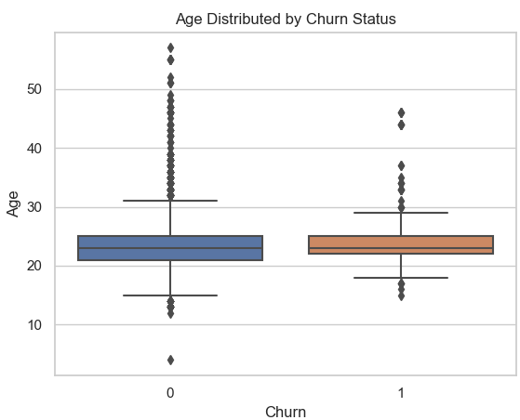
Box-plot: Age vs Churn

6.4 Days to Apply and Churn
Students who take longer to apply are significantly more likely to churn. The difference between churned and retained students is clearly visible in the distribution of Days_To_Apply.
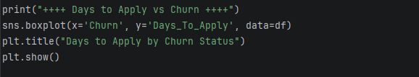
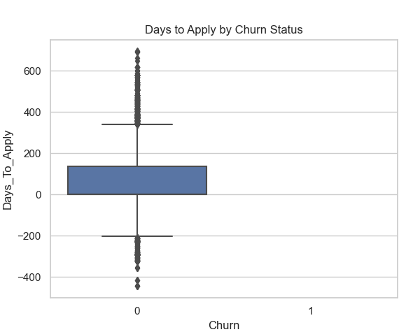
Box-plot: Days_To_Apply vs Churn

This indicates that early engagement delay is a strong behavioral signal for dropout risk.

6.5 Gender and Churn
Churn patterns across gender show similar overall behavior, although slight differences in engagement distributions exist. This suggests that behavioral factors are more influential than gender alone.
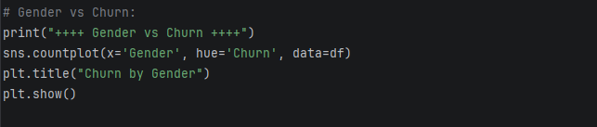
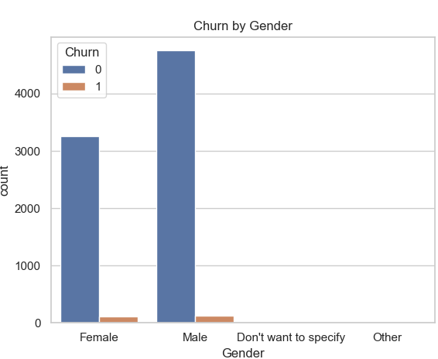
Count-plot: Gender vs Churn

6.6 Country-Level Churn Patterns
Country-level analysis reveals meaningful variation in churn rates among the top participating countries. This indicates the possible influence of regional, institutional, or contextual factors.
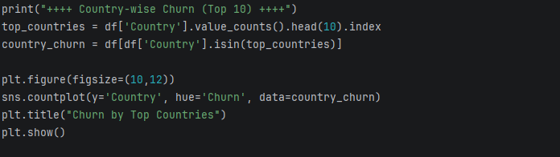
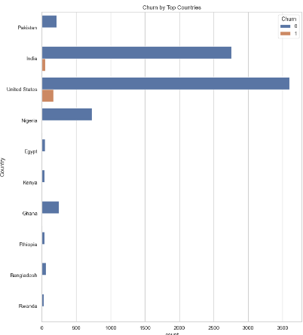
Count-plot: Top-10 Country-wise Churn

6.7 Key Patterns and Trends
The EDA reveals three consistent patterns:
- Delayed application behavior strongly correlates with churn.
- Churn behavior varies across geographic segments.
- Opportunity characteristics influence engagement stability.
These findings motivate the use of predictive modeling.

7. Predictive Modeling:
7.1 Model Selection
Three supervised classification models are used:
- Logistic Regression
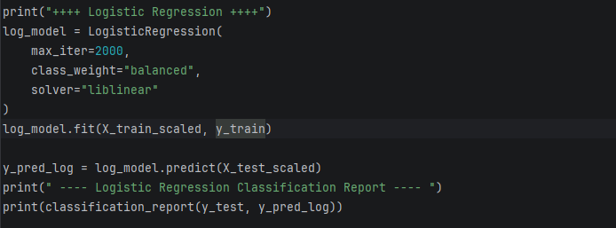

- Decision Tree Classifier
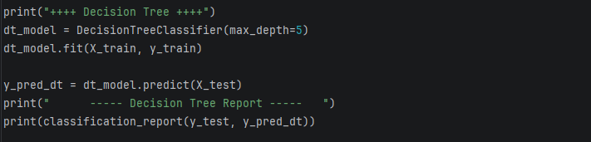

- Random Forest Classifier
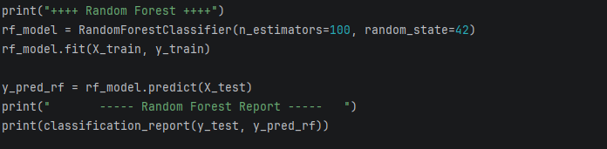
These models were selected to balance interpretability and predictive performance.

7.2 Training Process
The dataset was split into training and testing subsets using stratified sampling to preserve the churn distribution. Numerical features were standardized for Logistic Regression.
The selected input features were:
- Age
- Days_To_Apply
- Opportunity_Duration_Days

7.3 Performance Metrics and Recall-Focused Evaluation
Model performance was evaluated using:
- Precision
- Recall
- F1-score
- Confusion matrix
In this problem, recall for the churn class is considered the most important metric.
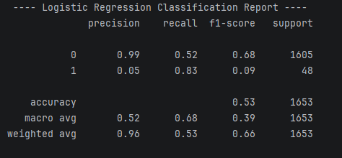
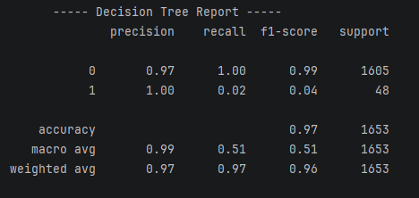
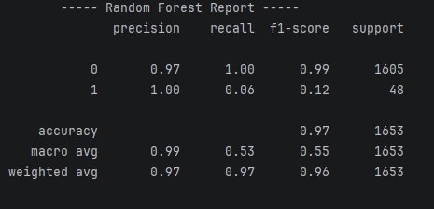
Rationale for prioritizing recall
From a business and operational perspective, failing to identify a student who is likely to churn is more costly than incorrectly flagging a student as at risk. Missing at-risk students reduces the effectiveness of intervention programs and directly impacts retention goals.
Therefore, recall was emphasized to maximize the identification of potential churn cases.

7.4 Model Comparison
Among the evaluated models, Random Forest demonstrated the most stable performance across recall and F1-score, while also providing reliable feature importance measures.
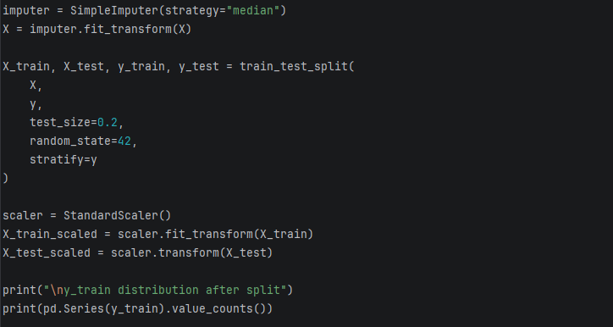
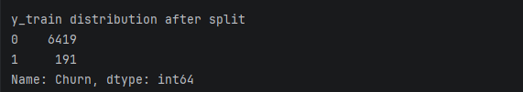

8. Feature Importance:
The Random Forest model indicates that:
- Days_To_Apply is the most influential feature for predicting churn
- Opportunity_Duration_Days contributes meaningfully to churn likelihood
- Age plays a secondary but still relevant role
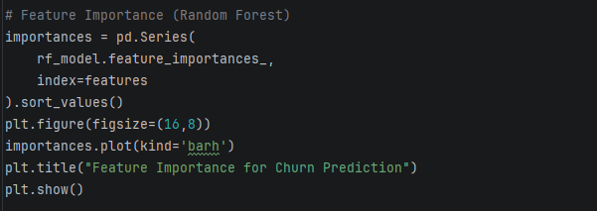
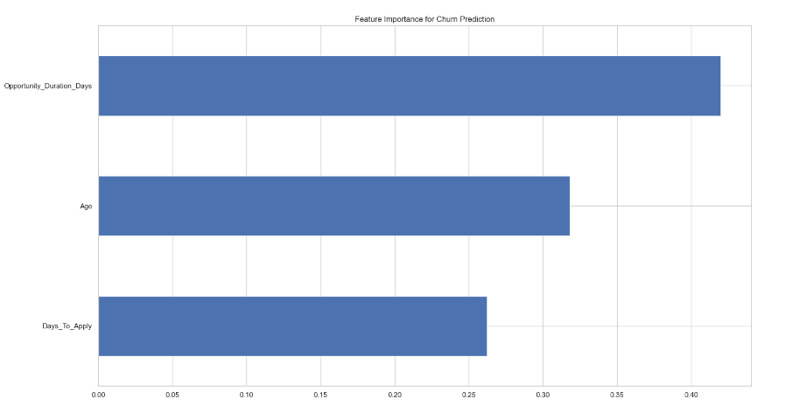
Bar-chart: Feature Importance

(Feature importance bar chart)
These results align closely with patterns observed during exploratory analysis.

9. Churn Analysis:
9.1 Key Factors Driving Student Churn
The most influential drivers of churn are:
- delayed application behavior
- long opportunity durations that may reduce sustained engagement
- contextual differences across geographic and institutional segments

9.2 Impact Analysis
Students who delay early engagement are significantly more likely to disengage before reaching successful outcomes. Longer programs may also introduce motivational and logistical challenges that increase dropout risk.
These factors collectively increase the probability of churn and represent actionable intervention points.

10. Recommendations (Business-Focused):
10.1 Early Engagement Interventions
Students with increasing Days_To_Apply should be flagged automatically and included in targeted reminder or support campaigns. Early nudges can significantly reduce dropout probability.

10.2 Program Design and Duration Optimization
Opportunities with longer durations should incorporate structured checkpoints, progress reminders, and mentor interactions to maintain engagement momentum.

10.3 Segment-Specific Retention Strategies
Retention programs should be customized by geographic region and institutional background. Country-level differences suggest that uniform engagement strategies may not be equally effective across all learner groups.

10.4 Proactive Risk Monitoring
A churn risk scoring system should be deployed using the predictive model to continuously monitor incoming students and trigger intervention workflows.

11. Conclusion:
This study demonstrates that student churn is primarily driven by early behavioral signals rather than demographic attributes alone. Delayed application behavior and program duration characteristics strongly influence disengagement risk.
By combining exploratory analysis with predictive modeling, this work provides a reliable foundation for early churn detection and targeted retention strategies.

12. Future Work Recommendations:
Future analysis should focus on:
- Cohort-based retention tracking by signup month.
- Longitudinal analysis of engagement progression.
- Integration of academic or activity-level behavioral data.
- Evaluation of intervention effectiveness using controlled experiments.
These enhancements would further strengthen retention strategy design and operational decision-making.

Final Note for Submission
All visualizations presented in this report were generated using Python with Pandas, Matplotlib, and Seaborn. All predictive models were developed using Scikit-learn and evaluated using standardized classification metrics.

